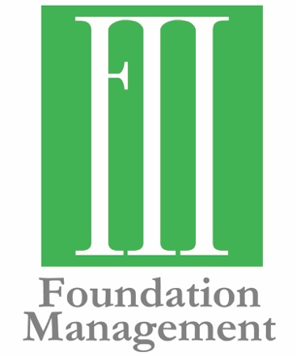
Contact Information:
Molly Helm, Communications Strategist
580-548-5400
molly@purpleinkconsulting.com

Foundation Management Holds Open House
Giving Group Moves to New Address

FOR IMMEDIATE RELEASE
May 31, 2019

OKLAHOMA CITY—Foundation Management recently moved to a new location, 1024 E. Britton Road, Suite 200, in Oklahoma City, and hosted a community open house to showcase their new space. Over 100 guests toured the building and received complimentary copies of Curbside Chronicle.
“We had outgrown our previous space and needed more meeting room,” said Frank Merrick, President and CEO. “This location gives us a room we can use for small trainings and allows all our staff to be in one building, where before we had part of our financial team working in a separate suite.”
Foundation Management serves foundations and other philanthropic clients in Oklahoma and four other states, while maintaining their home office in Oklahoma City.
###
Established in 2000, Foundation Management, Inc. helps private foundations and charitable organizations through consulting, facilitation and back-office support. The mission of Foundation Management is to exceed the expectations of those they serve. They work across communities to achieve philanthropic goals, using their expertise to form meaningful partnerships in the grant-making community. To learn more, visit fmiokc.com.

