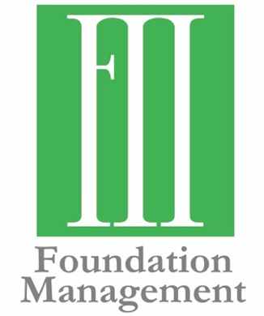
Contact Information:
Molly Helm, Communications Strategist
580-548-5400
molly@purpleinkconsulting.com

Tripp Hall Joins Foundation Management
Local Firm Expands Business Development

FOR IMMEDIATE RELEASE
July 15, 2019
OKLAHOMA CITY—Foundation Management announces the addition of a new staff member, Tripp Hall. Hall brings executive leadership experience and decades of philanthropy work, with an emphasis on business development and client service.
“Tripp is an asset to our clients and our work. His expertise, enthusiasm and experience in community giving will help foundations and others doing good with their giving. His leadership and community focus are an exciting addition to Foundation Management,” said Frank Merrick, President and CEO.
Hall has held leadership positions across both non-profit and for-profit organizations. He has expertise in strategic business planning and developing funding opportunities to drive organizational growth and success. He will focus on assisting current clients and developing new relationships in Oklahoma and the region.
“My goal is to provide a personal touch that further develops the relationship of trust and respect,” says Hall. “My hope is to provide direction and guidance to the client while fully understanding and appreciating the clients wishes and the mission of the foundation. My promise is to be of service to the client and always respect client wishes.”
Hall’s career includes more than two decades in development at the University of Oklahoma and he is co-owner of RJH Realty and Investments in Norman. He contributes substantial time to community board service, including Norman Music Festival, Assistance League of Norman, the Oklahoma Foundation of Excellence and the Oklahoma Arts Institute.
###
Established in 2000, Foundation Management, Inc. helps private foundations and charitable organizations through consulting, facilitation and back-office support. The mission of Foundation Management, Inc., is to exceed the expectations of those they serve. They work across communities to achieve philanthropic goals, using their expertise to form meaningful partnerships in the grant-making community. To learn more, visit fmiokc.com.

