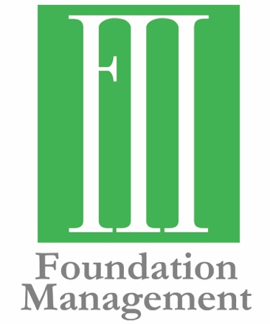
Contact Information:
Molly Helm, Communications Strategist
580-548-5400
molly@purpleinkconsulting.com

Merrick Family Foundation Celebrates 70 Years of Giving

Four Generations of Supporting Oklahomans

FOR IMMEDIATE RELEASE
November 14, 2019

OKLAHOMA CITY— This year marks seven decades of giving for the Merrick Foundation. Established by Ward S. Merrick, Sr. as a memorial to his father, the foundation now has $10.5 million in assets and has given over $20 million in grants to more than 300 nonprofit organizations since its inception in 1948.

“My great-grandmother, Mrs. Elizabeth B. Merrick, wanted a way to continue my grandfather’s legacy,” says Frank Merrick, board member of Merrick Foundation and founder of Foundation Management. “What a testament to their investment that the foundation has grown to what it is today and that it now involves 16 family members, plus others. The family, now in its fourth generation since inception, has a board that never met its original funders but carries on their wishes and works together for the greater good.”

Honoring the life and work of F.W. Merrick, the Merrick Foundation gives to help Oklahomans by funding projects in human services, health and wellness, education and community development. The foundation has stayed true to its founder’s vision by focusing grantmaking in southern Oklahoma, and some statewide organizations that increase the quality of life for the state.
Their support of Oklahoma State University as OSU worked to improve the health of students at the Stillwater campus serves as an example of how focused grantmaking could be a model and encourage student health initiatives across the entire state. A core belief of the Foundation is to support self-sufficiency and the Foundation prefers grantmaking to support organizations that help customers/clients grow so that they no longer need the services the organizations provide.

“Being a third-generation member and president of a family foundation brings me great pleasure and joy. Seeing the metamorphosis of the Merrick Foundation over the last 25 years has been amazing and rewarding. We adhered to our mission through four generations and we have excelled at it. Seeing our board actively involved in different forms of philanthropy outside their board duties shows me they have bought into the philosophy of giving back. The fact that our family members take an active role in our support of non-profits across Oklahoma gives me confidence in the future. For this I am most grateful,” says Rick Coe, current Merrick Foundation Board Chair.
Awarding grants to charitable organizations that foster independence and achievement and stimulate educational economic and cultural growth is especially meaningful to the Merrick Foundation. Many years ago, the Foundation agreed to fund the feasibility study for the possibility of building a natural history museum. The study showed there was support from both University of Oklahoma donors and the City of Norman, ultimately resulting in the Sam Noble Museum of National History.

“The Merrick Foundation has helped launch programs, built sustainable initiatives through partnerships with strong nonprofits, and the best part is we are just getting started,” says Will Merrick, fourth generation board member and Vice President of Foundation Management. I only wish my great-grandparents could see what their initial investment has become.”

###
Established in 2000, Foundation Management, Inc. helps private foundations and charitable organizations through consulting, facilitation and back-office support. The mission of Foundation Management is to exceed the expectations of those they serve. They work across communities to achieve philanthropic goals, using their expertise to form meaningful partnerships in the grant-making community. To learn more, visit fmiokc.com.

