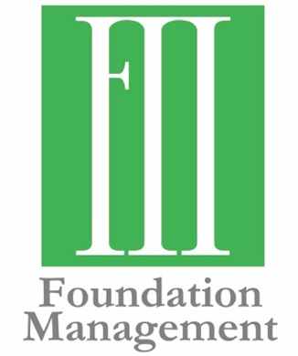
Contact Information:
Molly Helm, Communications Strategist
580-548-5400
molly@purpleinkconsulting.com

Foundation Management Welcomes Michael L. Meadows
Business Development Expands to Texas

FOR IMMEDIATE RELEASE
December 3, 2019

OKLAHOMA CITY—Foundation Management announces the addition of Michael L. Meadows as Vice President. Meadows will work from the Dallas area and focus on business development outside of Oklahoma. He will assist current clients and develop new relationships in Texas and the region.
“We welcome Michael to our growing team. He is the perfect addition, blending philanthropy, business acumen and client services,” said Frank Merrick, President and CEO. “Foundation Management serves foundations primarily in the central and southwestern part of the United States and having Michael working from Texas gives our clients someone closer to them.”
Meadows’ background of leading nonprofit and public entities for more than 30 years gives him a wide-ranging perspective. Prior to joining Foundation Management, Michael was Senior Vice President and Private Wealth Advisor at Westwood Holdings Group, a publicly traded global asset management firm. He created and led Westwood’s Foundation and Philanthropic Advisory Services, where he advised more than 20 private foundation and nonprofit clients, as well as philanthropic individuals and families.

His professional experience in nonprofit management includes leadership positions as the President and CEO of the Dallas Zoological Society, Executive Vice President for Southwestern Medical Foundation, and Director of Development for The University of Texas at Dallas. He began his career as a Development Officer for The University of Texas at Austin, where he graduated with a Bachelors of Arts degree from the College of Liberal Arts.

Meadows has experience with private foundations and has served as a trustee for The Meadows Foundation and as a non-family trustee for two other family foundations. He also serves on the board of the National Fish and Wildlife Foundation, where he chaired the Foundation’s grants committee.

As a volunteer, Meadows has served on numerous boards and advisory boards. He currently serves on the boards of the Momentous Institute, the Mike A. Myers Foundation, the National Center for Family Philanthropy, and The Arts Community Alliance (TACA), and on the advisory boards of the Communities Foundation of Texas, RGK Center for Philanthropy and Community Service at The University of Texas at Austin, and SMU DataArts, the National Center for Arts Research at Southern Methodist University.

Through his work and volunteer roles, Meadows has developed an understanding of best practices and the responsibilities of a fiduciary. He works with individuals, families and organizations to identify shared values, develop common goals and achieve results.

“Over the past 20 years, I have consulted and collaborated with Frank Merrick and his associates at Foundation Management on numerous occasions. I have deep respect for their knowledge, skills and character and feel blessed to join such an outstanding and dedicated team of professionals. I look forward to working with them to serve and advise successful individuals and families who want to make a positive and lasting difference in their communities through their philanthropy,” said Meadows.

###
Established in 2000, Foundation Management, Inc. helps private foundations and charitable organizations through consulting, facilitation and back-office support. The mission of Foundation Management is to exceed the expectations of those they serve. They work across communities to achieve philanthropic goals, using their expertise to form meaningful partnerships in the grant-making community. To learn more, visit fmiokc.com.

